Experiment-6
Description:
Jenkins is an open source automation tool written in Java programming language that allows continuous integration.
Jenkins builds and tests our software projects, which continuously making it easier for developers to integrate changes to the project, and making it easier for users to obtain a fresh build
It also allows us to continuously deliver our software by integrating with a large number of testing and deployment technologies.
Jenkins offers a straightforward way to set up a continuous integration or continuous delivery environment for almost any combination of languages and source code repositories using pipelines, as well as automating other routine development tasks.
With the help of Jenkins, organizations can speed up the software development process through automation. Jenkins adds development life-cycle processes of all kinds, including build, document, test, package, stage, deploy static analysis and much more.
Jenkins Freestyle Project is a repeatable build job, script, or pipeline that contains steps and post-build actions. It is an improved job or task that can span multiple operations. It allows you to configure build triggers and offers project-based security for your Jenkins project. It also offers plugins to help you build steps and post-build actions.
The types of actions you can perform in a Jenkins build step or post-build action are quite limited. There are many standard plug-in available within a Jenkins Freestyle Project.
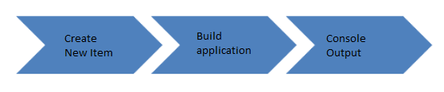

Procedure:
The freestyle build job is a highly flexible and easy-to-use option. You can use it for any type of project; it is easy to set up, and many of its options appear in other build jobs.
- Launch ec2-Instance:
- Go to compute service in your AWS Console. Select on Launch Instance.
- Select the type of Instance you want
- Select the type of storage you want for your Instance.
- Select the VPC and subnet where you want your instance.
- Select the capacity of your Instance.
- You can add tags and names to identify your Instance.
- Configure your security group to allow access to SSH and All Traffic
- Take a last review for the instance settings and Click on Launch.
- Select a key pair for accessing the Instance. Create new if you don't have a key pair and click on launch Instance.
- It will take 2-5 minutes and your instance will be ready.
- Open the putty.
- Run the command sudo su to provide the privileges to the root device.
- Run the command yum update -y to update the EC2 instance
Install Jenkins:
- amazon-linux-extras install epel -y
- amazon-linux-extras install java11 -y
- amazon-linux-extras install java-openjdk11 -y
- java --version
- yum install jenkins -y
- sudo wget -O /etc/yum.repos.d/jenkins.repo https://pkg.jenkins.io/redhat-stable/jenkins.repo
- sudo rpm --import https://pkg.jenkins.io/redhat-stable/jenkins.io.key
- yum install jenkins -y
- systemctl restart jenkins
- systemctl status jenkins
- cat /var/lib/jenkins/secrets/initialAdminPassword
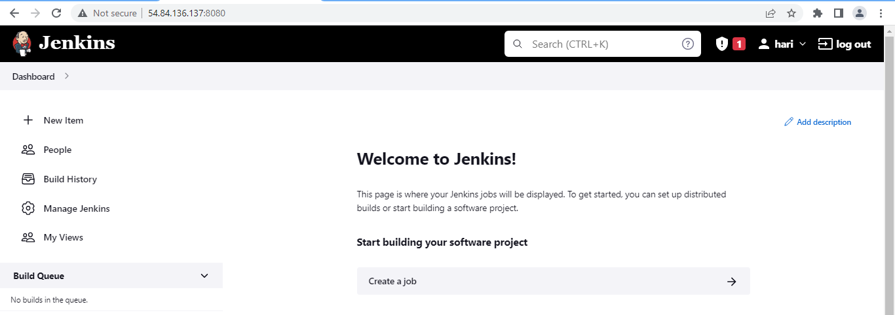
Create New Item
Click on “New Item” at the top left-hand side of your dashboard.
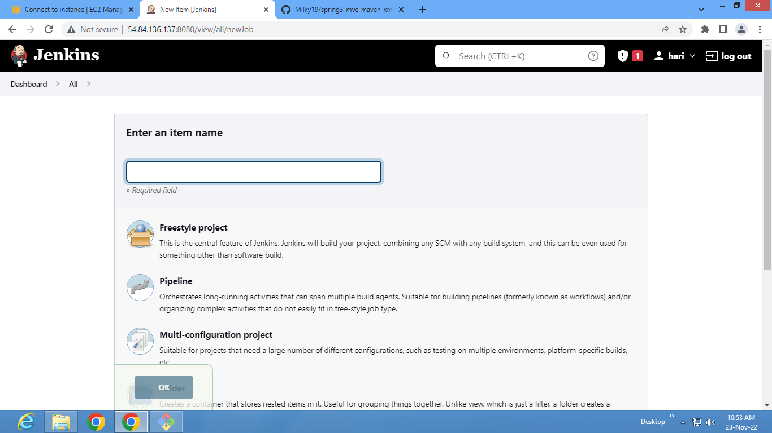
Enter Item details
- Enter the name of the item you want to create. We shall use the “Hello world”.
- Select Freestyle project
- Click Okay
Enter Project details
- Enter the details of the project you want to test.
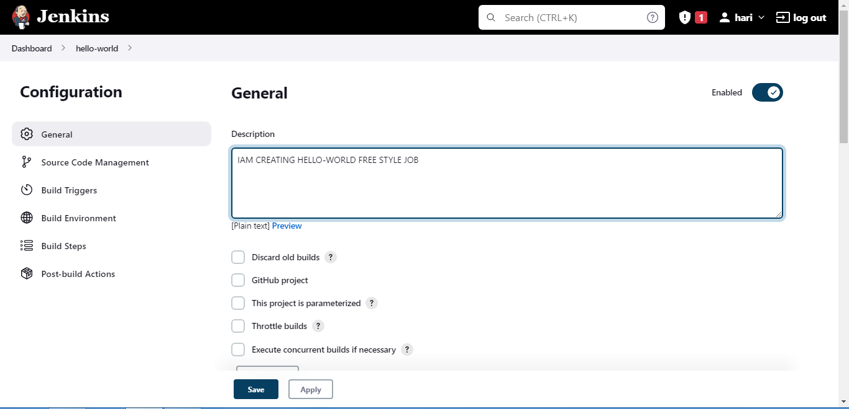
Enter repository URL
- Under Source Code Management, Enter your repository URL. We have a test repository located at Github
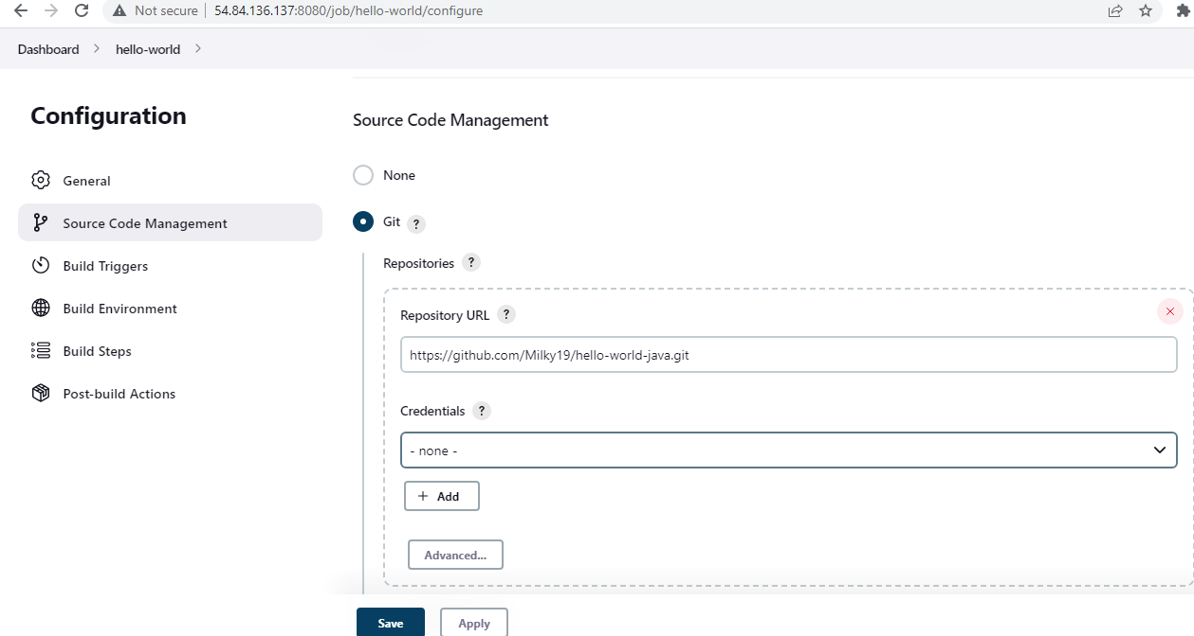
- It is also possible for you to use a local repository.
- If your GitHub repository is private, Jenkins will first validate your login credentials with GitHub and only then pull the source code from your GitHub repository.
Tweak the settings
- Now that you have provided all the details, it’s time to build the code. Tweak the settings under the build section to build the code at the time you want. You can even schedule the build to happen periodically, at set times.
- Click on “Add build step”
- Click on “Execute shell command” and add the commands you want to execute during the build process.
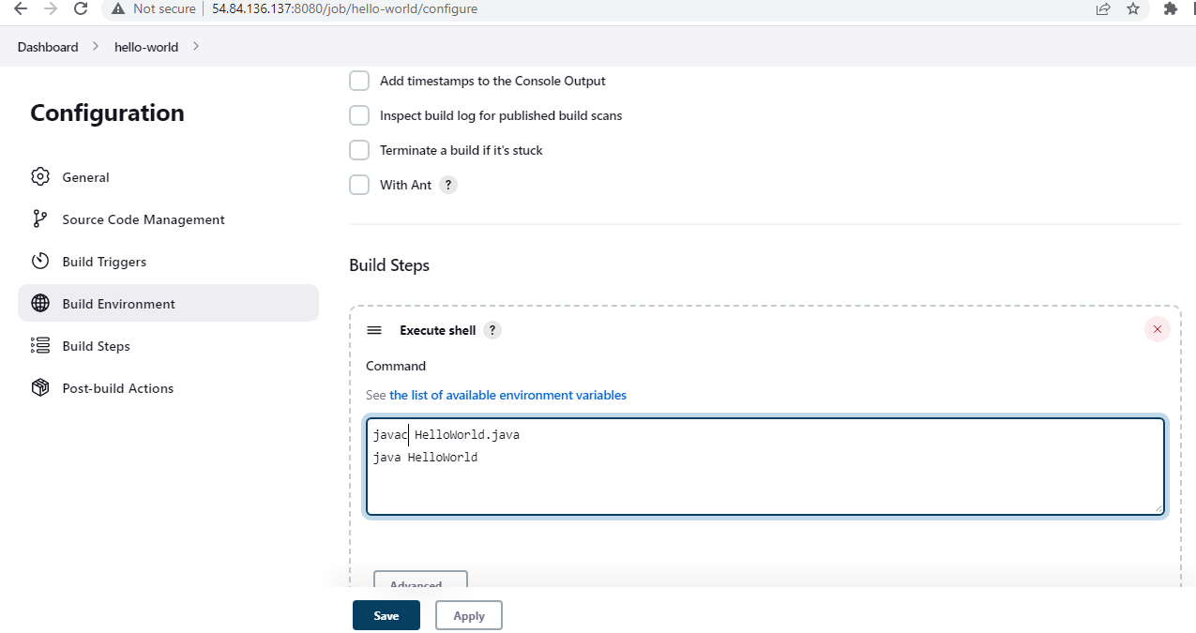
- Here, I have added the java commands to compile the java code.
- I have added the following linux commands:
- javac HelloWorld.java
- java HelloWorld
Save the project
When you have entered all the data,
- Click Apply
- Save the project.
- Build Source code
- Now, in the main screen, click the Build Now button on the left-hand side to build the source code.

Check the status
- After clicking on Build now, you can see the status of the build you run under Build History.
See the console output
- Click on the build number and then Click on console output to see the status of the build you run. It should show you a success message
Sample Output:
